GitHub Actions CI/CD Pipeline for Flask Application
GitHub Actions CI/CD Pipeline for Flask Application
Name: Saranya S ID: 13487
Date: 04th July 2026

Step 1: Open Your Flask Project Folder
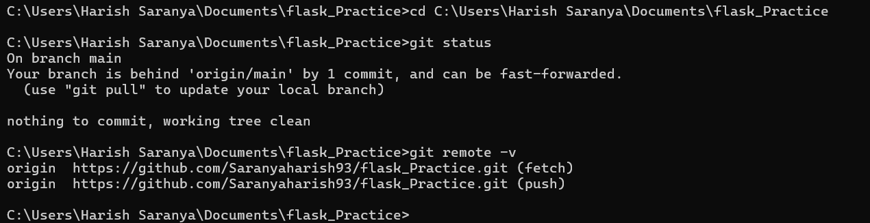
Step 2: Create Staging Branch
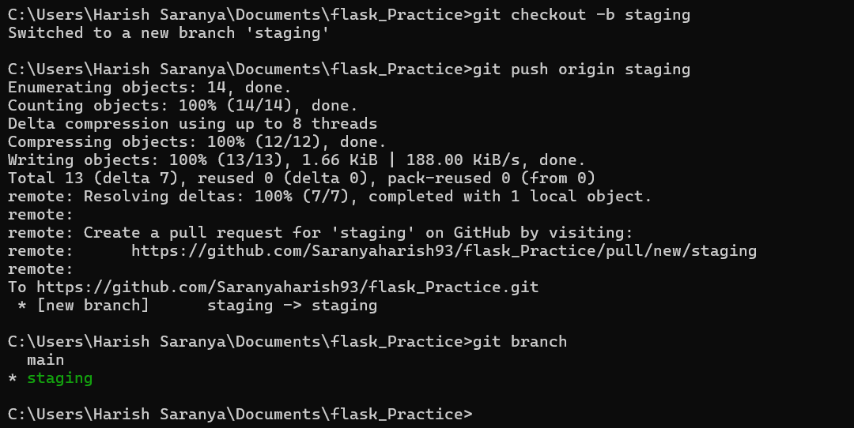
Step 3: Add GitHub Actions YAML
name: Flask CI/CD Pipeline
on:
push:
branches:
- main
- staging
tags:
- "v*.*.*"
pull_request:
branches:
- main
- staging
jobs:
build-test:
runs-on: ubuntu-latest
services:
mongodb:
image: mongo:6
ports:
- 27017:27017
steps:
- name: Checkout Code
uses: actions/checkout@v4
- name: Set Up Python
uses: actions/setup-python@v5
with:
python-version: "3.10"
- name: Install Dependencies
run: |
python -m pip install --upgrade pip
pip install -r requirements.txt
- name: Run Tests
run: |
pytest
- name: Build Application
run: |
echo "Build completed successfully"
deploy-staging:
needs: build-test
runs-on: ubuntu-latest
if: github.ref == 'refs/heads/staging'
steps:
- name: Checkout Code
uses: actions/checkout@v4
- name: Deploy to Staging
run: |
echo "Deploying Flask app to staging environment"
echo "Staging deployment completed"
deploy-production:
needs: build-test
runs-on: ubuntu-latest
if: startsWith(github.ref, 'refs/tags/v')
steps:
- name: Checkout Code
uses: actions/checkout@v4
- name: Deploy to Production
run: |
echo "Deploying Flask app to production environment"
echo "Production deployment completed"
Step 4: Commit Files
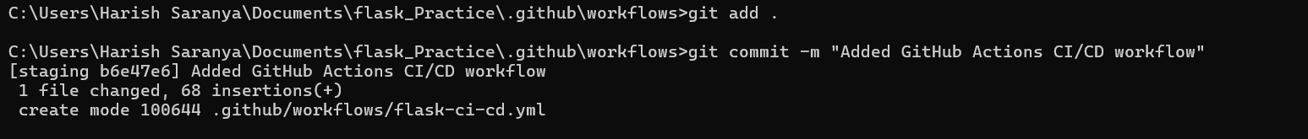
Step 5: Push to Staging Branch
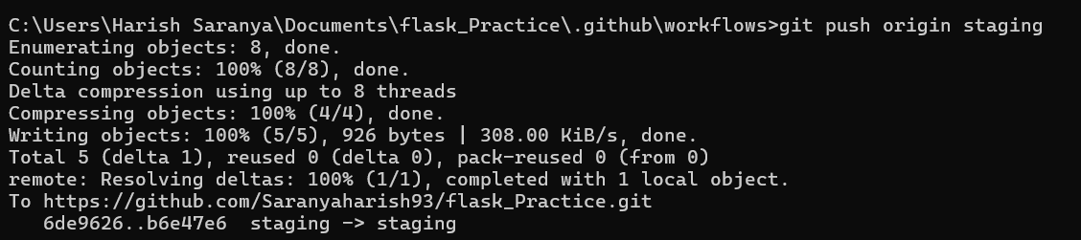

Step 6: Add GitHub Secret
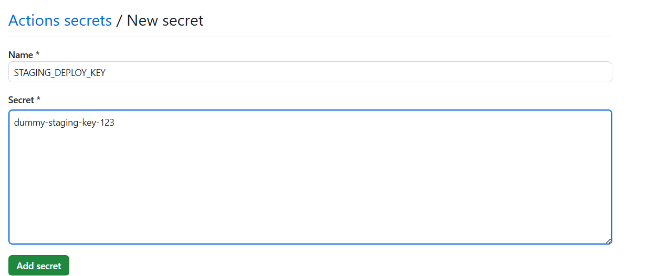

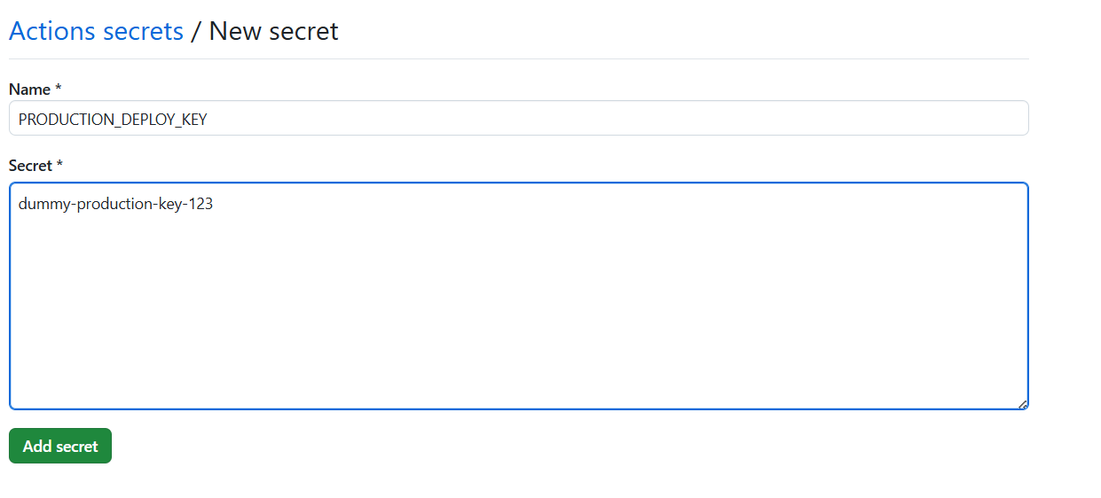
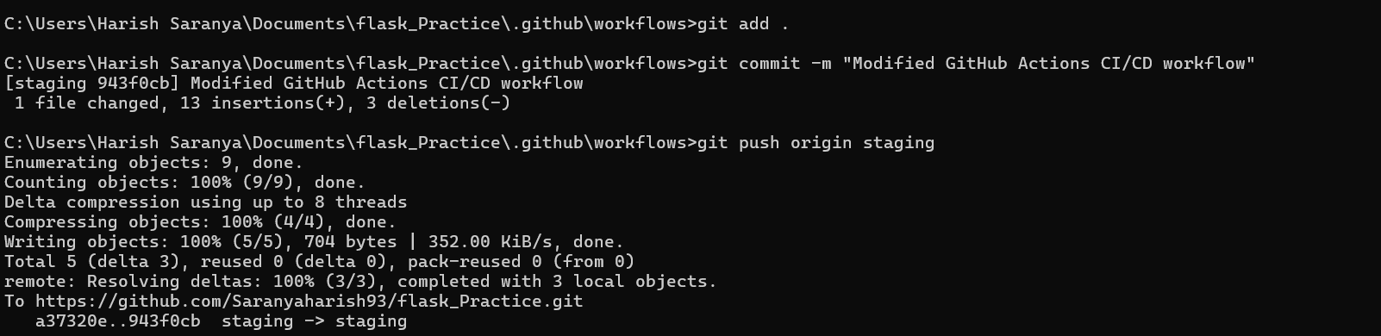

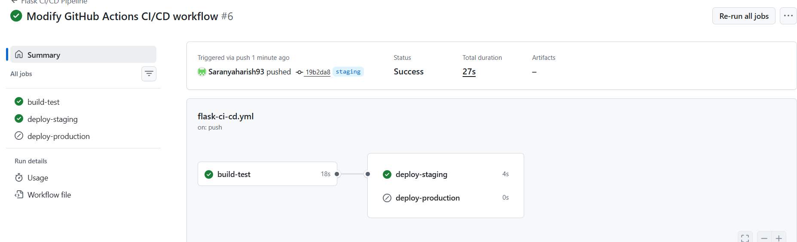

Step 7: Merge to Main
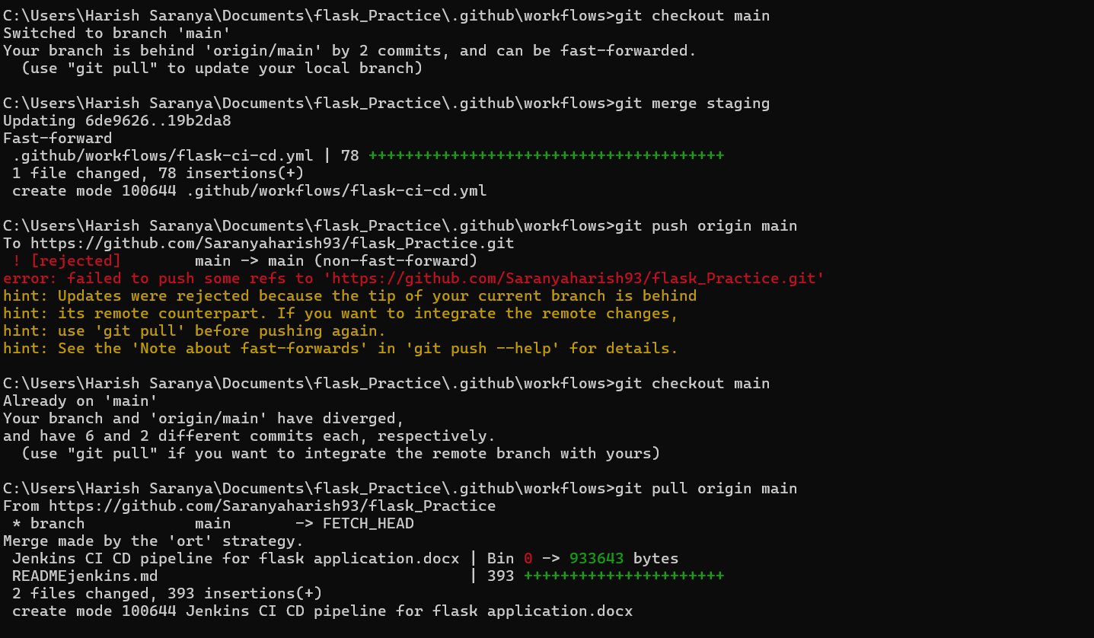
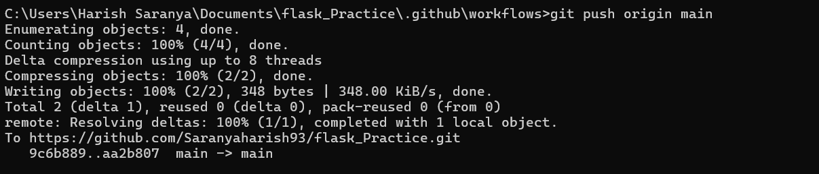
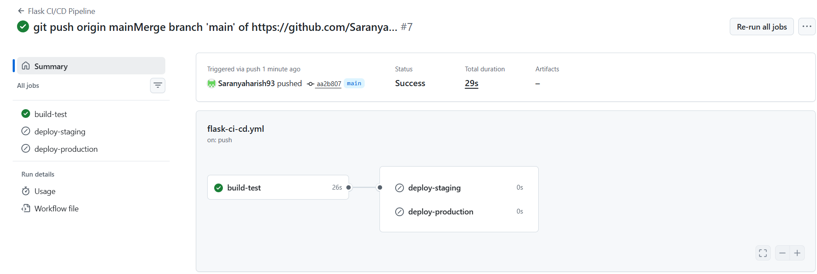

Step 8 : Create Production Release Tag
